

TEMENOS T24

Stream

User Guide

Table of Contents

Tree Table Widget and Code

Introduction 3

Preface 3

Overview 3

Assumptions 3

Getting Started 3

Installation 3

Adding Tree Table Widget 5

# 

# Introduction

## Preface

This User Guide is intended for Developers and provides the step by step instructions for adding the Tree Table widget that allows a flat structured data set to be displayed in a tree form.

## Overview

The purpose of the tree table widget is to allow a flat structured data set to be displayed in a tree form, so that rows can be expanded and displayed to the user if they wish to see them. This makes it particularly useful for large data sets, where the data can be categorized.

## Assumptions

It is assumed that you are familiar with the edgeConnect Editors and have working knowledge on edgeConnect.

# Getting Started

## Installation

For manual installation:

1. Copy **com.temenos.widgets.tables.treeTable** folder in your widgets folder (Ex: /{your project/templates }).
2. Restart IDE.

For auto-installation:

1. Run IDE.
2. Make sure ‘**Switch Monitor on/off**’ is checked.
3. Download and copy the widget **com.temenos.widgets.tables.treeTable.zip** to the monitored folder.

(Navigate to **Tools** -> **Options** -> **Auto-install** tab and set in ‘**Download Location**’ the folder where you copied the widgets). There is no need to restart IDE.

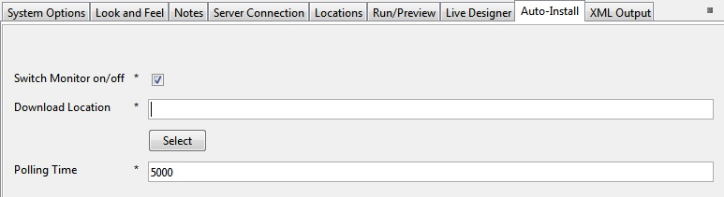

## Adding Tree Table Widget

Create a table in edgeConnect using the standard table. The data group that contains the data to be displayed must have two extra data items namely:

* A unique id (this can be the instance)
* The parent id

These are used by the widget to turn the structure into a tree. Make sure the widget is installed before opening the display properties for the table in the **Presentation Editor**:



When you select **Tree Table**, a new tab will appear called **Widget Details**. This will let you choose the data items that define the row ID and the parent ID.

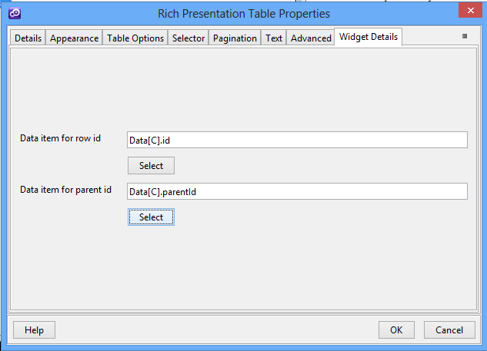

Running this project produces the following results:



The table is collapsed to begin with. Clicking on the arrow on the left expands that row to display child rows (rows that have the first row as the parent).

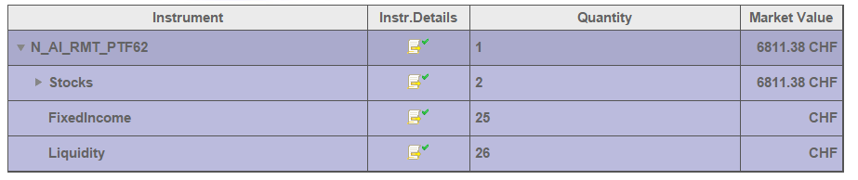

Expanding “Stocks” results in:

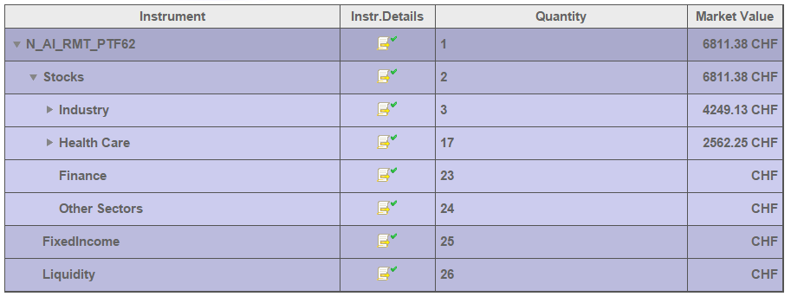

To expand to a row by default, requires a selector data item to be specified on the table whose value represents the id of the row to reveal. This is why using instances for IDs is good idea.

The styling of the table is added in the header part of the widget. Each level of nesting gets its own class, so that you can set styles on rows, as you go deeper into the tree.

The first column must have the questions set to read-only in the IDE to render accordingly to the widget’s design.